Story
Name | Manpreet Kaur
Date | 19 July 2026
Project Name | Food Ordering Behaviour and Consumer Trends: A Structured Analysis of Choices and Habits

A Tableau Story — Analyzing Order Value and Customer Behavior Across Indian Cities — was built to guide stakeholders through a logical, sequential narrative that turns the raw transaction records into a cohesive customer-behaviour story.
ACTIVITY 1 : Story Design
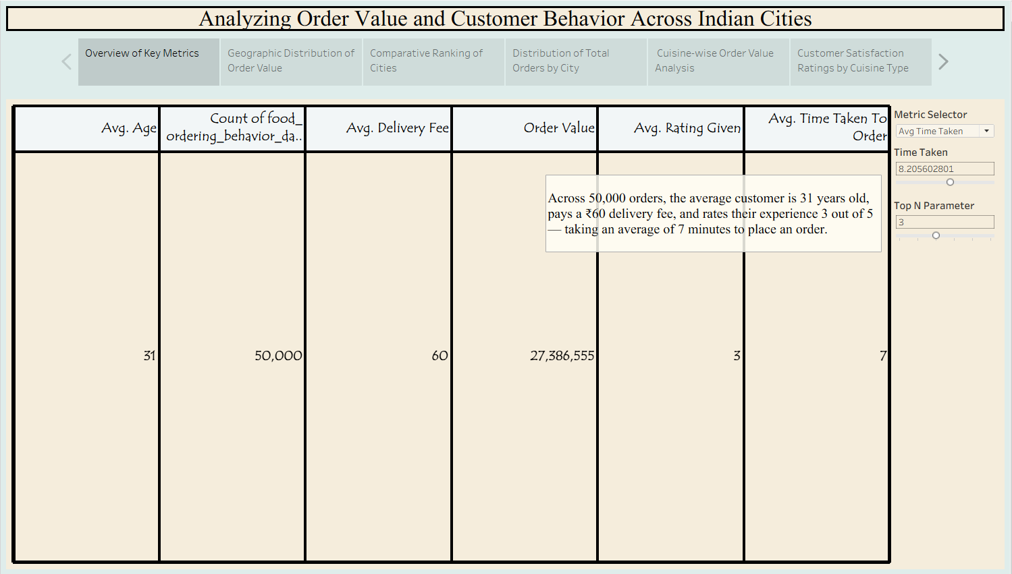

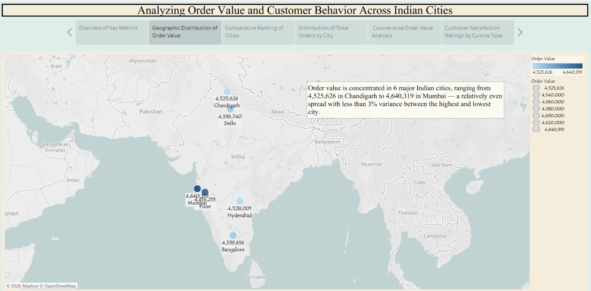

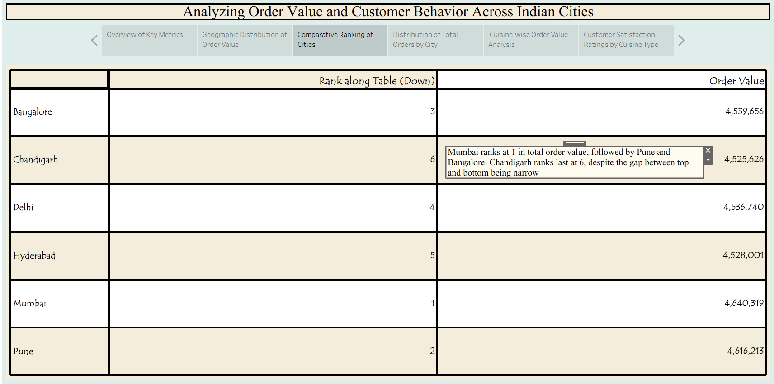

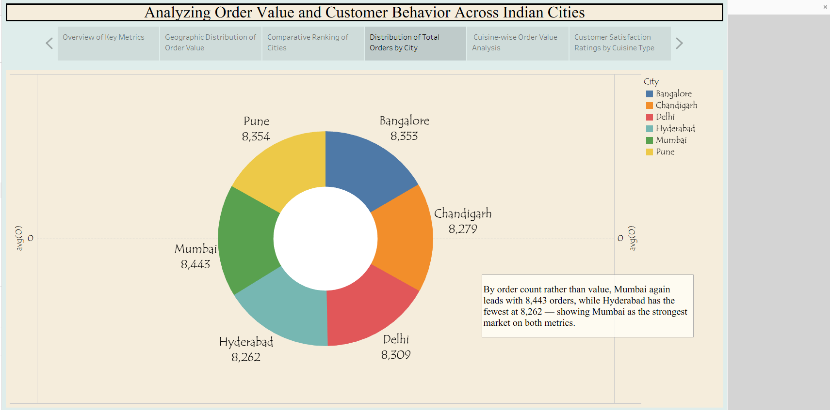

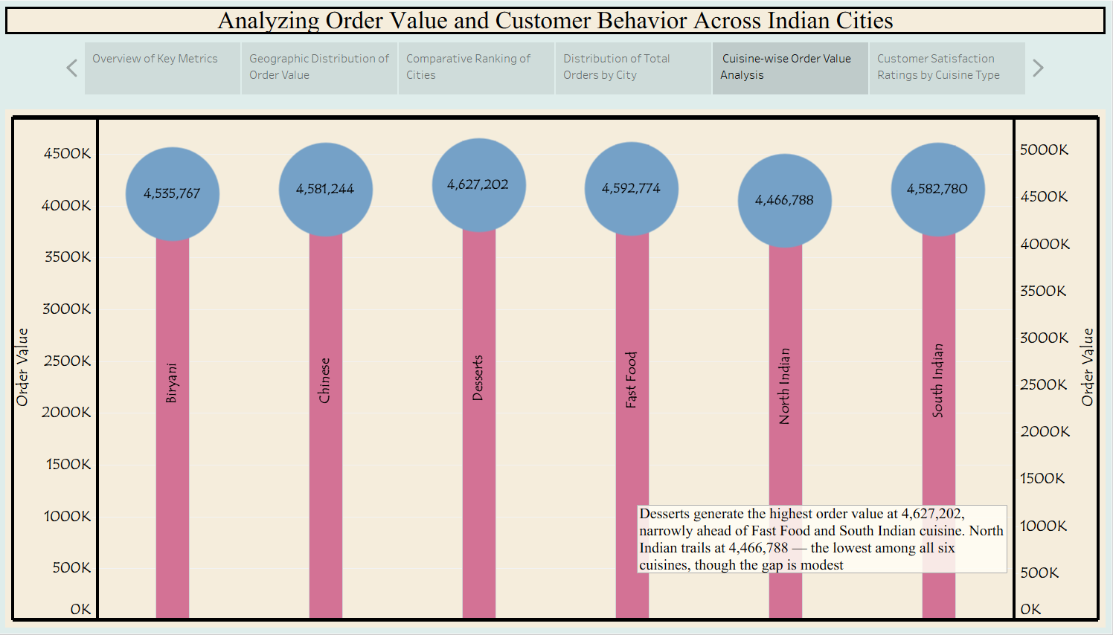

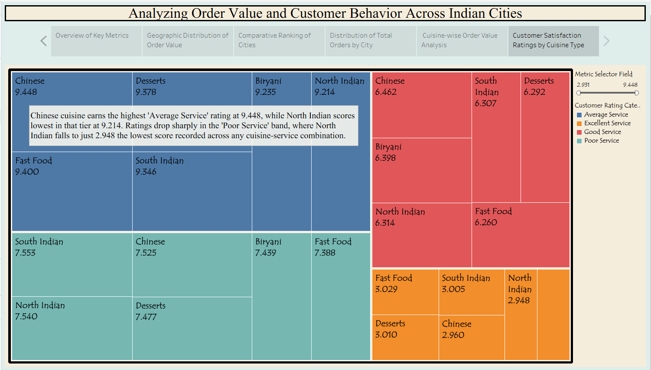

Tableau Story Narrative & Observations
By leveraging the sequential story point structure in Tableau, the Analyzing Order Value and Customer Behavior Across Indian Cities presentation guides business stakeholders through a logical progression of order metrics, turning raw transaction records into a cohesive customer-behavior narrative. Based on the interactive story points, here are the core business observations:
- Baseline Customer Profile Is Remarkably Consistent (Overview of Key Metrics, Q1): Across all 50,000 orders, the average customer is 31 years old, pays a ₹60 delivery fee, and rates their experience 3 out of 5 — taking roughly 7 minutes to place an order. This tight clustering suggests a fairly homogeneous customer base rather than distinct behavioral segments at the aggregate level.
- Geographic Spread Is Even, Not Concentrated (Geographic Distribution & Comparative Ranking, Q2–Q3): Order value is spread across 6 major Indian cities with less than 3% variance between the highest (Mumbai, ₹4,640,319) and lowest (Chandigarh, ₹4,525,626) performing markets. Mumbai leads on both order value and order count (8,443 orders), followed closely by Pune, while Chandigarh trails on both metrics — pointing to a genuinely national demand pattern rather than one dominant hub.
- Value and Volume Move Together, But Not Perfectly (Distribution of Total Orders by City, Q4): Mumbai's leadership in order count mirrors its lead in order value, reinforcing it as the strongest market on both dimensions. However, cities like Bangalore and Pune show that high order counts don't always translate to proportionally higher value, hinting at differences in average basket size across regions.
- Cuisine Preferences Show a Narrow but Meaningful Spread (Cuisine-wise Order Value Analysis, Q5): Desserts generate the highest order value at ₹4,627,202, narrowly ahead of Fast Food and South Indian cuisine. North Indian trails at ₹4,466,788 — the lowest among all six cuisines — though the modest gap suggests fairly balanced demand rather than a single runaway favorite.
- Satisfaction Ratings Diverge Sharply by Service Tier (Customer Satisfaction Ratings by Cuisine Type, Q6): Chinese cuisine earns the highest "Average Service" rating (9.448), while North Indian scores lowest in that tier (9.214). The pattern inverts in the "Poor Service" band, where North Indian falls to just 2.948 — the lowest score recorded across any cuisine-service combination — flagging North Indian as the cuisine most vulnerable to service-quality complaints despite steady order value.
Activity 2:
Publish Story on Tableau Public and Paste Public link below
https://public.tableau.com/app/profile/manpreet.kaur7362/viz/Food_Ordering010_/Story1?publish=yes

